NIMO Release Notes

Change History and Database compatibility

Version | Date | Comments | Database Version
2.5.0 | 4/1/08 | Initial Release | 2.4.0
2.5.1 | 4/23/2008 | Units Model | 2.5
2.5.3 | 5/30/08 | Frequency Model | 2.5
2.5.4 | 8/4/2008 | Patch release | 2.5
2.6.0 | 8/22/2008 | Price Utility | 2.6

Version 2.6.0

This release implements the Price Utility functionality, allowing users to create price types with associated awareness, persuasion, and utility.

Client

The functionality for the Price utility project is described in the document “Price Utility.docx”. In addition, help pages have been added the provide user details.

The new Price Type can be found under the product node in the model tree.

Panel Tools
A cosmetic change in the client was performed to unify how actions are performed in each model panel. Most panels now have a tool strip across the top that allow users to perform actions within the context of the objects in that panel.

Fixes in this release

Attribute tau is no computed in the client correctly when calculating the expected volume. This brings the client into alignment with the engine which uses the tau adjusted attribute utilities when computing the expected volume.

Engine

Besides the price utility, the calculation for the seasonal flow through rate was modified in the engine to agree with the BASES formulae. If S is the allotted amount of modification that is apportioned to frequency amount and M is the total demand multiplier then the actual multipliers for frequency and units are

Frequency Demand Multiplier = M^{S}
Units Demand Multiplier = M^{(1 – S)}

Version 2.5.4

This release was a bug fix release to remedy issues found in 2.5.3

Client

MAPE calculation causes crash of application.
This issue would arise sporadically when during a MAPE calculation. The issues was found whenever there was a date mismatch between the real and simulation data.

Copy Model causes crash of application
This was a result of a misnamed variables used in the of units and frequency model.

Engine

Seasonality fix

In the previous version the demand modification was equally split between units and frequency. But since total volume is the product of units and frequency the portion that is applied to frequency needed to be amended to yield the correct total volume change.

If S is the allotted amount of modification that is apportioned to frequency amount and M is the total demand modification then the actual amount of frequency modification is

Freq. Demand Modification = S*M / ( 1 + ( 1 –S)*M)

This chart shows total units purchased for several runs of a test model. The modification was fixed at 20%. The seasonality weight had values 0, 50, 85, 100. A run with no modification is included for comparison.
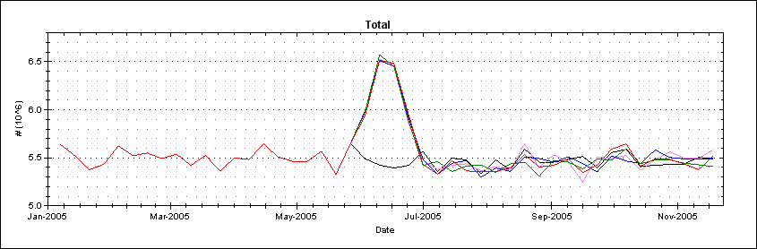
Total Units purchased

This next chart shows the number of shopping trips for the same runs. Note that in this case the number of shopping trips does increase when more weight is applied to frequency.
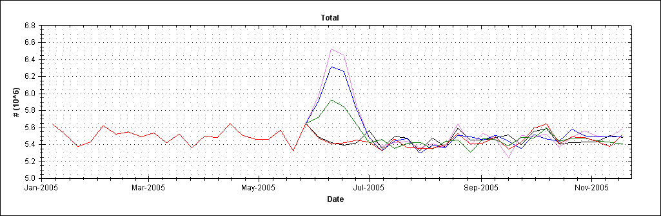
Number of shopping trips

Expected Volume Calculation

An error was found with the calculation with the expected volume in the engine. The issue was a mismatch between the attributes used in the Mean units purchased and the utility applied to the product during the choice math. This has been fixed so that both use the same calculation.

Dollar Sales

In MarketSim the price for a product is considered to be the dosage price – in NIMO the price for the product is considered to be the unit price. The previous versions of the NIMO engine used the MarketSim calculation, this version calculates the dollars sales by multiplying the units sold by the product price.

Last simulation date to write
In previous version in order to maintain consistency with NIMO version 2.3, the engine would perform a write on the last simulation date. This was modified so that the engine always performs writes at equal increments as specified by the use.

This eliminates an issue where the calculated values were not accurate on the last time step.

Version 2.5.3

Client

New features

Frequency Model
Segments have a Min and Max Percentile that determines from where the frequency distribution is drawn.

The default values for the Min and Max Percentile are 0 and 100 respectively.

In addition Segments also have a Flow Through Weight which determines for reach segment the amount of modifications to make to the purchase frequency when comparing the expected volume to the actual volume.

The default value for the flow through weight is 0.

Seasonality

External factors have two new options: Frequency and Units and Frequency.

Frequency adjusts the volume by changing the shopping frequency of the consumer.

Units and frequency adjusts the volume by changing both the number of units purchased and by changing the shopping frequency. The amount of volume apportioned to frequency is determined by the Seasonal Shopping Weight parameter. This parameter can be found in the Model Summary.

The default value for the Seasonal Shopping Weight is 85.

SSIO
There is now a special NIMO spreadsheet template for NIMO specific fields.

On the products sheet the base price, eq. units and pack size may be added for each product. The columns can be omitted if desired.

Segments have a min and max percentile for the frequency as well as the flow through weight. These columns can be omitted if desired, errors will occur but the segments will still be imported.

For the external factors a new column determines which type of external factor is desired. The values for the types are strings.
UnitsPurchased | Frequency | PriceSensitivity | FrequencyAndUnits

The template has added data validation so only these values can be used.

Engine

Frequency Model
Please see the specification for details.

Version 2.5.2
(internal release)

Version 2.5.1

Client

Pack Size added to Products.

Ability to reset simulations added to database utilities.

Engine

Features
Units model added. Please see the BUF specification for details. This version does not include the seasonality and flow through calculations.

Bugs fixed
Percent at promo and display price was using ACV distribution. The default for NIMO is to use a normalized distribution.

When “Reset Panel Data” is selected for a simulation and the start date of the simulation is the same as the start date of the model then the panel data is reset after the model has been initialized.

Version 2.5.0

Client

This is the NIMO release of the MarketSim Client. It is intended to be used with the NIMO Engine version 2.5.

This version of the client does not require the user to set the custom configuration, the client will automatically start up in NIMO mode. Other then this difference there are no other differences between this client and the version 2.4 client.

Engine

This version of the MarketSim simulation engine is intended for use by BASES and for incorporating specific algorithms into the model. It has been built on the framework initially constructed in the MarketSim Engine version 2.4, but has been modified to use the original choice logic. All features available in the 2.4 engine are available in this release with the following addition.

Events by Product

In 2.4 events by a specific product were ignored, this was due the Pantry model limitation. In version 2.5 events by product are allowed.

